Project Design Phase-II
Technology Stack (Architecture & Stack)
Date | 01 October 2026
Team ID | [SWTID-20026-8917]
Project Name | Blog Nest – AI-Powered Blogging & Content Management Backend
Maximum Marks | 4 Marks

Technical Architecture:
Blog Nest is a headless REST API built in layers: clients call the Express routes, middleware secures each request, controllers and services apply business logic, and data is stored in MongoDB. AI features call Google Gemini through an AI Flow service.
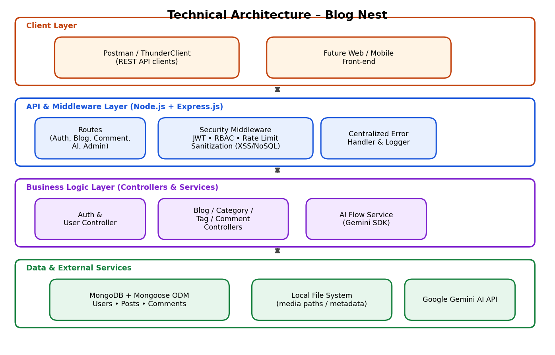
Figure 1: Technical architecture of Blog Nest
Table-1 : Components & Technologies:
S.No | Component | Description | Technology
1 | User Interface | Blog Nest is a headless backend; the API is consumed and tested through REST clients. A web/mobile front-end is planned as future work. | Postman / ThunderClient
2 | Application Logic-1 | Authentication, JWT issuance/validation, role-based access control | Node.js, Express.js, jsonwebtoken, bcrypt.js
3 | Application Logic-2 | Blog, category, tag, comment and media-metadata controllers (MVC) | Node.js, Express.js
4 | Application Logic-3 | AI Flow service for blog generation and summarization | Google Gemini AI (Generative AI SDK)
5 | Database | Stores Users, Posts and Comments as schema-driven documents | MongoDB with Mongoose ODM
6 | Cloud Database | Optional hosted deployment of the same MongoDB database | MongoDB Atlas (compatible; local MongoDB used in development)
7 | File Storage | Image/asset paths and metadata are stored with posts; files kept on the local filesystem | Local filesystem
8 | External API-1 | Generates blog content and article summaries from prompts | Google Gemini API
9 | External API-2 | Not used in this version | N/A
10 | Machine Learning Model | Generative large language model used for blog writing and summarization | Google Gemini generative model
11 | Infrastructure (Server / Cloud) | Application deployed on a local server; runs on Windows, macOS, Linux.  Local Server Configuration: Intel i5 (8th Gen)/Ryzen 5, 8–16 GB RAM, 1 GB storage, Node.js v16+, npm v8+ | Local (cloud-ready, stateless design)
Table-2: Application Characteristics:
S.No | Characteristics | Description | Technology
1 | Open-Source Frameworks | Open-source runtime, web framework and ODM | Node.js, Express.js, Mongoose
2 | Security Implementations | JWT authentication, bcrypt password hashing, role-based access, input sanitization (XSS / NoSQL injection), rate limiting on sensitive routes | JWT, bcrypt.js, sanitization middleware, rate limiter, OWASP-aligned practices
3 | Scalable Architecture | Stateless REST API in a modular MVC layout; can be scaled horizontally | MVC, Node.js/Express
4 | Availability | No server-side session state, so instances can be restarted or replicated behind a load balancer when deployed | Stateless API design
5 | Performance | Schema-driven Mongoose queries; rate limiting; caching of popular posts planned as an enhancement | Mongoose, MongoDB indexes, rate limiter
References:
https://nodejs.org/docs • https://expressjs.com • https://mongoosejs.com • https://ai.google.dev • https://c4model.com/

